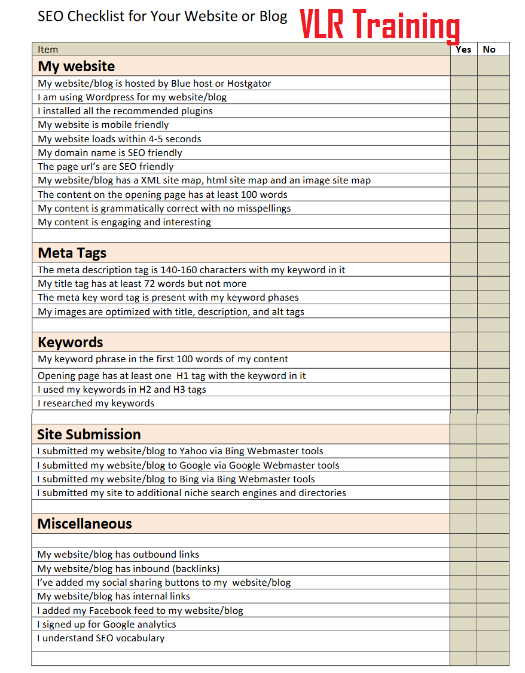

What Is bot

What is domain and page authority?

What is clocking

What is alt?

What is delisting

What is directory?

What is doorway page?

What is algorithm?

What is spider and bot?

Heading tags

Kda keyword density analyger

Keyword phrase

Keyword stuffing

Link popularity

Meta tags

Meta robots tag

A tag no follow

Organic links

Page rank

Reciprocal lin

Site map

Serp

Spam dexing

Stop word

Title